
<Project Name>

Schedule Management Plan

<Insert Project Logo here>

<Month, Year>

Health and Human Services Agency, Office of Systems Integration

Revision History
Revision History
Revision/WorkSite # | Date of Release | Owner | Summary of Changes
Initial Draft |  | OSI - PMO
[Remove template revision history and insert Project Communication Plan revision history.]

Approvals
Name | Role | Date
[Insert Project Approvals here.]

Template Instructions:
This template offers instructions, sample language, boilerplate language, and hyperlinks written in 12 point Arial font and distinguished by color, brackets, and italics as shown below:
- Instructions for using this template are written in purple bracketed text and describe how to complete this document. Delete instructions from the final version of this plan.
- Sample language is written in red italic font and may be used, or modified, for completing sections of the plan. All red text should be replaced with project-specific information and the font changed to non-italicized black.
- Standard boilerplate language has been developed for this plan. This standard language is written in black font and may be modified with permission from the OSI Project Management Office (PMO). Additional information may be added to the boilerplate language sections at the discretion of the project without PMO review.
- Hyperlinks are written in blue underlined text. To return to the original document after accessing a hyperlink, click on the back arrow in your browser’s toolbar. The “File Download” dialog box will open. Click on “Open” to return to this document.

Table of Contents
1 Introduction 4
1.1 Purpose 4
1.2 Scope 4
2 Participants 4
2.1 Roles and Responsibilities 4
3 Schedule Development Process 6
3.1 Create High-Level Milestone Schedule 6
3.2 Create Work Breakdown Structure (WBS) 8
3.2.1 Project WBS versus Contract WBS 9
3.2.2 WBS Element Numbering Methodology 12
3.2.3 WBS Dictionary 12
3.3 Create Resource Breakdown Structure 13
3.4 Create Responsibility Assignment Matrix (RAM) 14
3.5 Create and Integrate Schedule 14
3.5.1 Date, Sequence, and Link Activities 15
3.5.2 Estimate Duration 16
3.5.3 Duration Rules 17
3.5.4 Resource Planning Rules 18
3.5.5 Validate Schedule 18
3.5.6 Integrate Schedules 18
3.6 Baseline Schedule 19
4 Scheduling Development Tool 20
4.1 Scheduling Development Tool Description 20
4.2 Scheduling Tool Usage 20
5 Schedule Input Monitoring 20
5.1 Compare Schedule Status to Time Status Reports 20
5.2 Monitor Prime Contractor’s Schedule 21
6 Schedule Management and Control 21
6.1 Schedule Control Techniques 22
6.2 Schedule Control Products 26
6.3 Schedule Change Request Process 26
6.4 Update Schedule 26
6.5 Establish New Schedule Baseline 27
6.6 Archive Schedule Change Support Materials 27
7 Schedule Status Reporting 27
7.1 Monthly Project Reports 27
7.2 Monthly Metrics and Trend Analysis 27
7.3 Schedule Oversight Reports 28
8 Schedule Closing 28
8.1 Closing Reports 28
8.2 Archive Schedule Data and Tools 28
Appendix A: Glossary & Acronyms 1
[Create additional appendices as necessary.]

Introduction

Purpose
[This template facilitates the development of a Schedule Management Plan (SM Plan) at the earliest stages of your project. Your Schedule Management Plan may require updates during the course of your project so that it continually reflects your chosen course of action.
Explain the purpose of the Schedule Management Plan.]
This document describes the <Project Name> Schedule Management Plan (SM Plan). The purpose of the SM Plan is to provide guidance on how to develop, manage, and control the schedule throughout the project life cycle.

Scope
[Define the scope of the Schedule Management Plan (SM Plan) – what is included and what is not. The OSI PMO assumes the project will use a traditional scheduling methodology that tracks time and resources, rather than an Earned Value Management System (EVMS) that integrates cost and schedule. This SM Plan can be expanded by the project or Project Scheduler to include EVMS if desired. The Schedule Management Supplemental on the OSI Best Practices Website is a companion resource to this template. The supplemental offers more examples and instruction on the High-Level Milestone Schedule, the Work Breakdown Structure, and the estimating activity durations.
This template is designed for the reader who is familiar with principles of basic schedule management.]
The SM Plan identifies the process and procedures used to manage the schedule during the course of the <Project Name>. In addition to defining the schedule development approach, the plan defines who is responsible for tracking and reporting schedule progress, how schedule updates are received and incorporated, how variances and changes will be addressed, and how to baseline the schedule. The plan briefly describes the project’s schedule management tool.

Participants

Roles and Responsibilities
[List the responsibilities of each party below as they relate to schedule management and control for your project. Delete parties not applicable to your project.]
Schedule-related responsibilities of staff and stakeholders involved in managing and controlling the project schedule are noted as follows:
State Responsibilities:
- Project Sponsor – will review and approve the final baseline schedule and only significant changes through the schedule change control process.
- Project Director – will approve the project’s Schedule Management Plan, baseline schedule, and any significant changes through the schedule change control process. The Project Director is ultimately responsible for the schedule and to complete the project according to the schedule.
- Project Manager – will oversee, provide input to the schedule (via the change control process) and review schedule status reports provided by the Project Scheduler. The Project Manager will also evaluate time-risk recommendations from the Project Scheduler to avoid schedule issues.
- Functional Managers – will notify the Project Manager and Project Scheduler of workload changes that may affect the schedule. The Functional Manager will also review and approve time estimates provided by staff for the schedule.
- Project Scheduler – will lead the schedule management effort, sponsor task-tracking activities, facilitate schedule status communication, and maintain the projects’ scheduling tool and supporting documentation. The Project Scheduler will make recommendations to the Project Manager to avert schedule variances that may adversely affect the project budget, expenditures, or critical path.
- Quality Assurance – will periodically audit scheduling practices to validate compliance with this Schedule Management Plan.
- Project Staff – will provide accurate time estimates for the beginning and completion of work as well as status reports on the achievement of those times.
- Office of Technology Services (OTech) – will (if project participant) provide timely accurate time and resource estimates to the scheduling and Project Manager as requested.
Prime Contractor Responsibilities
- Prime Contractor (PC) – will report to the State Project Manager and Project Scheduler scheduled status of their contracted obligations as stated in the RFP and contract. The PC will develop the Contract Work Breakdown Structure (WBS) and manage their internal activities to the timely accomplishment of the schedule, of which status shall be reported weekly and monthly, notifying the state of potential or actual schedule variances.
Oversight Responsibilities
- Independent Project Oversight Consultant (IPOC) – will provide oversight of the project and report findings including schedule status to the California Technology Agency (TA) on a monthly basis via the Independent Project Oversight Report (IPOR).

Schedule Development Process
[Referring to your schedule development process inserted as Figure 1, explain how the schedule will be developed for your project.]
The schedule development process is comprised of six development steps. Each step taken generates a schedule subcomponent that can stand alone to inform the project team of that aspect of the final schedule. When integrated form the basis for the approved working version of the final schedule known as the Baselined Schedule. Figure 1 depicts the order and the individual products generated during the schedule development process. Each step and resulting product is explained in this section…

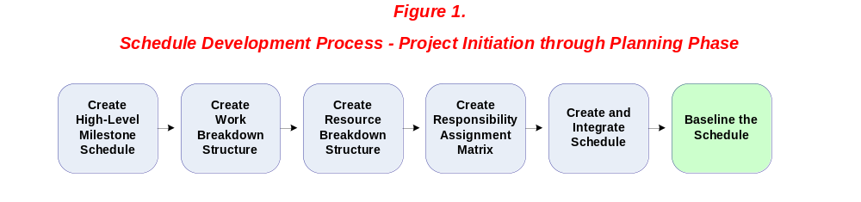

Create High-Level Milestone Schedule
[The High-Level Milestone Schedule (HMS) is a visual representation of anticipated critical activities, milestones, and interfaces across the entire project. It is developed by the State during the concept or acquisition phase to provide the project team with the earliest possible view of project’s most critically timed activities. At this stage, the date for a critical activity may not be known, but the visual representation of the activity among all the activities on the chart will enable the team to conceptualize the relative flow of important events.
The HMS displays both the project’s expected flow of critical activities as well as the vertical integration of related deliverables from other existing or pending contracts. It displays what the State is responsible for in parallel with the Contractor’s responsibilities. It sets a clear expectation early on of critical timing between project deliverables and key events. This chart makes a valuable contribution to the Feasibility Study Report (FSR), Request for Proposal (RFP) and to stakeholders interested in the global timing of key project events over the life of the project.
Update the HMS during the course of the project if critical activities, interfaces, or dates change.
Delete the HMS in the example provided in the sample content below and insert your own. Define the critical milestones depicted. Describe the interfaces between contracts as well as known constraints all schedules must accommodate. Define who is responsible for maintaining an accurate version of the HMS, what will trigger the update, and the approval process for the revision. See the Schedule Development Supplemental for an explanation of the example HMS.]

Figure 2 displays the HMS for the <Project Name>. The HMS shows the interface and timing of critical State and Contractor deliverables, events, and milestones. Contract A and B are underway and will provide deliverable inputs into the final system this project will deliver.

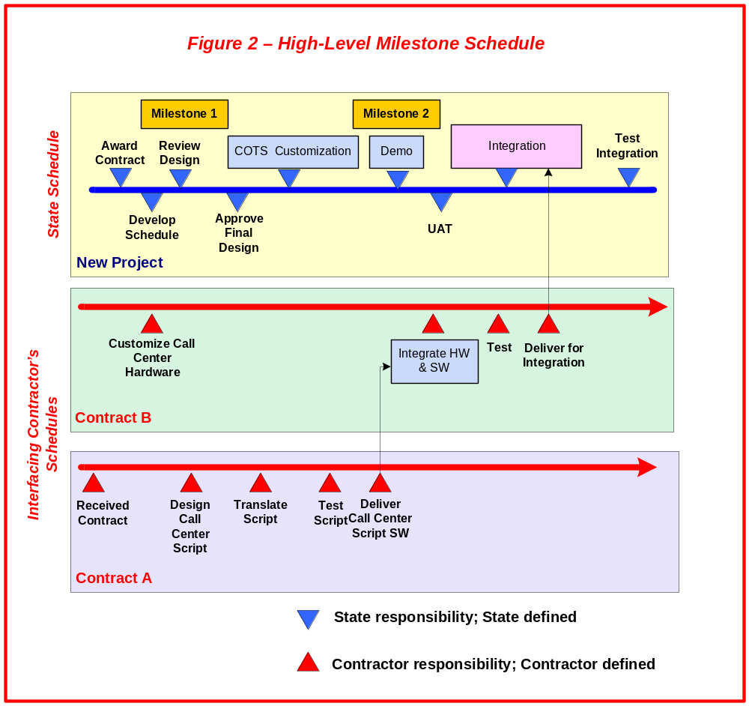

Create Work Breakdown Structure (WBS)
[The WBS is a hierarchical-tree diagram that organizes and defines the scope of the project. It also becomes the skeletal format for the schedule. The WBS is made up of two separate WBS’. The first is the Project WBS created by the State, the second is the Contract WBS created by the Prime Contractor. The State produces the top three levels of the WBS tree showing the Main, Major, and Sub-deliverables of the final system with the “Main Deliverable” being the final system. These levels show what the State expects to receive in the final system.
The Prime Contractor produces levels four through six (or lower) showing their approach to developing the deliverables or work products that comprise the final system/main project deliverable. The Activities, Tasks, and Sub Tasks in these lower levels are stated as the resulting work product/outcome created by the activity, task, or sub-task rather than as the work effort itself. When grouped together vertically, these levels form a package of work (or work package) associated with the deliverable above. This package of work can be priced out and build progress tracked.
Define how the project’s deliverable-oriented WBS will be generally structured. Include a breakdown of the project’s main deliverable. See the Schedule Management Plan Supplemental for additional information on the WBS.]
The <Project Name> uses a deliverable-oriented work breakdown structure (WBS) to best reflect the scope of project. The WBS is created by decomposing the project’s main deliverable – House – into its sub components using a hierarchical-tree format. The upper levels of the WBS breakdown the deliverables (or outcome - not necessarily “contracted deliverables”) into sub-deliverables while the lower levels of the WBS depict the activities and tasks that must be accomplished to create the deliverable (or outcome) shown on the upper levels of the WBS.
The breakdown for the <Project Name> WBS is as follows:
- The top of the chart is headed by the name of the Main Deliverable (final system) – House.
- The House is decomposed into the Major Deliverables (major elements in the scope of work) necessary to build the house.
- The major work products/deliverables are decomposed into the Sub-deliverables necessary to build the deliverables on the level above.
- The sub-deliverables are decomposed into the Activities necessary to build the sub-deliverable.
- The activities are decomposed into the Tasks that must be done to accomplish the activity.
- The tasks are decomposed into the Sub-tasks that must be done to complete the task above.
This breakdown is represented in Figure 3.

Figure 3 – General Work Breakdown Structure

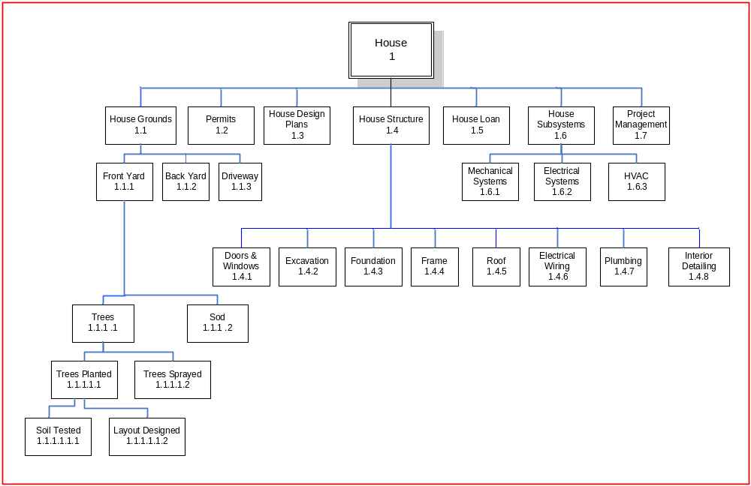

Project WBS versus Contract WBS
[A well-defined Project WBS enables the customer to see exactly “what” will be built. A well-defined Contract WBS enables the State project team to see “how” it will be built. Defining both well also enables a project manager to create measurable entry and exit criteria for beginning and ending work.
The work of the Contract WBS should be stated as the work outcome or work product rather than the work effort itself (i.e., “Tree Planted” rather than “Plant tree”). Stating the Contract WBS tasks in the past tense reinforces the deliverable-oriented approach irrespective of methodology or process (which can change).
Describe how the Project and Contract WBS will be created and who will provide each. Show the Project and Contract WBS for one of the deliverable branches of your WBS or include the full WBS in an appendix. WBS software can assist in the creation and import of your diagram. See the Schedule Management Supplemental for more information on the Project and Contract WBS.
Levels 1, 2, and 3 are documented by the State and are collectively referred to as the Project WBS. The Project WBS reflects the project’s main deliverable (final system), the major deliverables to the main deliverable, and the sub-deliverables that comprise each major deliverable. A deliverable is not necessarily a “contracted deliverable” but rather a major sub-set of the final system. The Project WBS shows “what” must be built.
Levels 4, 5, and 6 are documented by the Prime Contractor and are collectively referred to as the Contract WBS. The Contract WBS shows the activities, tasks, and sub-tasks that must be completed by the contractor to build the deliverables on the Project WBS. The Contract WBS demonstrates how the Prime Contractor will approach building the deliverables on the Project WBS. The Contract WBS shows “how” it will be built.
The Prime Contractor will build the Contract WBS using the SMART technique. Each activity, task, and sub-task should be Specific, Measureable, Attainable, Realistic, and Time-Constrained…
Figure 5 breaks out the State-generated Project WBS from the Prime Contractor-generated Contract WBS:
Figure 4 – WBS Delineated into Project WBS and Contract WBS
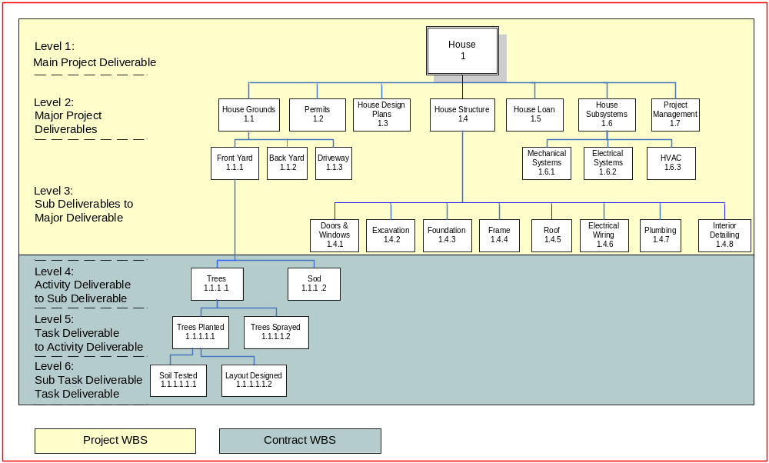

WBS Element Numbering Methodology
[Create and document a WBS numbering methodology that distinguishes between WBS levels and provides traceability once the WBS has been converted to a schedule. A numbering system also ensures the Contract WBS (and later, contractor schedule) logically flow out of the State’s WBS and seamlessly integrate into the State’s schedule.]
To create traceability between the WBS and the schedule and to distinguish between levels, all boxes on the WBS, known as “elements” will be numbered using the methodology shown in Table 1…

Table 1. Element Numbering Methodology

 | WBS Level | Element # for Level | Subject matter for Level | Example
Project WBS created by State | Level 1 | 1 | Main Project Deliverable | 1 - House
Project WBS created by State | Level 2 | 1.1 | Major Deliverables to the Main Deliverable | 1.1 - House Grounds
Project WBS created by State | Level 3 | 1.1.1 | Sub-deliverable (or Sub-component) to Major Deliverables | 1.1.1 -Front Yard, 1.1.2 - Rear Yard, 1.1.3 - Driveway
Contract WBS created by Prime Contractor | Level 4 | 1.1.1.1 | Activity Deliverable to Sub-Deliverable (or Sub-Component) | 1.1.1.1- Trees Planted
Contract WBS created by Prime Contractor | Level 5 | 1.1.1.1.1 | Task Deliverable to Activity Deliverable | - – Trees Delivered
Contract WBS created by Prime Contractor | Level 6 | 1.1.1.1.1.1 | Subtask Deliverable to Task Deliverable | 1.1.1.1.1.1 – Trees Ordered

WBS Dictionary
[In support of the final WBS, the State Project Manager and the Contractor will develop a WBS Dictionary to define the meaning of each element within their respective sections of the WBS. The hierarchical relationship between the WBS elements is replicated in the dictionary using the WBS element number to organize the table. Each WBS element should be cross-referenced in the WBS dictionary to other dependent WBS elements. Update the WBS Dictionary as needed so that it continually reflects the current scope of the project and WBS.
Define and explain the format of the WBS Dictionary. Include a sample of the dictionary to illustrate its format. Attach your WBS dictionary as an appendix to this document. State who is responsible for updating the WBS Dictionary when the WBS changes. Explain the update process. See the Schedule Management Supplemental for an example of a WBS Dictionary.]
The WBS dictionary for the <Project Name> defines the meaning of each WBS element and the lower-level deliverables. The WBS dictionary is ordered by element number for easy reference. The element name, responsible party, associated elements, and contract line item and/or requirements are recorded. A brief description of the element is included and it details the statement of work, cost estimate, quality requirements, technical content, start and end dates, resource requirements, and performance measurement criteria.
The following is an excerpt from the WBS dictionary for one element:
Table 2. WBS Dictionary
WBS Element # | WBS Element Name | Resp. Party | Associated Elements | Contract Line Item & Requirement
1.1.1.1.1 | Trees Planted | Prime | Trees 1.1.1.1  Soil Tested 1.1.1.1.1.1  Layout Design  1.1.1.1.1.2 | 14a) Trees will be planted…  Rqmt-256, 257, 258
Element Description
Tree of (x) variety embedded in front yard via hole 16” wide, 18” deep, spaced at least 10 feet from any adjacent tree or 3 feet from adjacent shrub…

Create Resource Breakdown Structure
[The Resource Breakdown Structure (RBS) is a hierarchical breakdown of project personnel. The RBS can be broken down to reflect the way the project resources are functionally organized. The RBS supplies the resource names for project schedule and it shows reporting lines and levels of authority in the project. It also provides the Project Manager with a comprehensive view of potential resources when building the schedule or addressing resource conflicts.
Insert a copy of your RBS or place it in an appendix. Define how the project’s RBS is structured and updated. Explain any constraints or caveats that may change the RBS in the future.] The RBS should be updated as people or roles change over the course of the project.
The Resource Breakdown Structure (RBS), similar to project organization chart, is a hierarchical tree diagram decomposed from major responsible project organization/group down to the work-performing individual. The RBS supplies the resource names for the project schedule. It is updated when project resources are added or deleted, or the reporting structure changes. The <Project Name> RBS is shown in figure…

Create Responsibility Assignment Matrix (RAM)
The Responsibility Assignment Matrix (RAM) correlates the tasks of reviewing and approving deliverables with the State parties that will perform these tasks as well as the Prime Contractor who will provide the deliverable.
The RAM is created by the State Project Manager and the functional manager. The tasks and resources shown on the RAM are transferred to the schedule as it is built. Since every deliverable shown on the RAM should also correspond to a deliverable on the WBS, including the corresponding WBS element number on the RAM will provide traceability between the RAM, the WBS, and ultimately the schedule.
The RAM chart can be found on the OSI Best Practices Website at http://www.bestpractices.osi.ca.gov/sysacq/documents.aspx?index=s under Staff Management Plan. Insert a copy of your RAM or include it in an appendix. Define who will ensure the ongoing accuracy of the RAM and how.]
The RAM for the <Project Name> correlates tasks of providing, reviewing, and approving deliverables with the parties responsible for these tasks…

Create and Integrate Schedule
[The Project WBS serves as the outline structure for the State’s schedule. The deliverables noted in the Project WBS on Levels 1 through 3 are replicated in a schedule format using a scheduling tool like MS Project. The WBS element numbers order the outline of this schedule with each level of the WBS shown as indented on the schedule. Figure 6 in the sample text depicts the Project WBS (broken down to level 3) replicated in MS Project.
Describe how the Project WBS is replicated in MS Project as the State’s schedule. Include a sample such as that shown in Figure 5 of the sample text in Section 4.2.]
Figure 6 shows the example WBS in Figure 5 formatted in Microsoft Project as a schedule (dates have not been set). The <Project Name> will apply the same approach…

Figure 5 – Project WBS Replicated as a Schedule

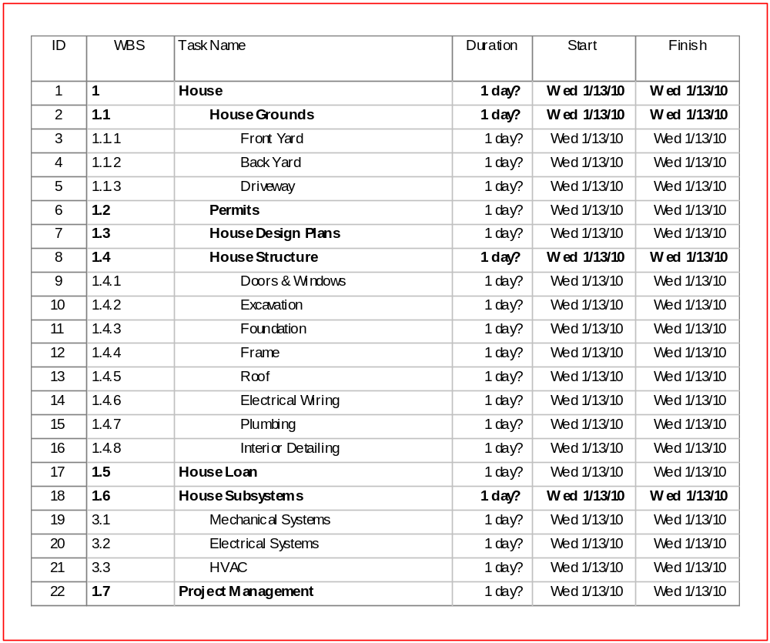

Date, Sequence, and Link Activities
[Upon replicating the WBS structure in a schedule format, date, sequence, and link the activities and tasks. In this section, define date, sequence, and linking rules scheduling staff will apply to create dependency relationships between tasks/deliverables.
Rather than imposing arbitrary, manually inserted dates, define whether the relationships between activities will be Finish-to-Start, Start-to-Start, Finish-to-Finish, or Start-to-Finish. Define how liberally constraints such as Start/Finish on, Start/Finish no later than, and Start/Finish no sooner than, will be applied to the schedule.]

There are four types of dependencies (logical relationships) used to create links between schedule tasks. The Finish to Start dependency is more commonly used for scheduling the <Project Name>.
- Finish-to-Start (FS): The initiation of the successor activity depends upon the completion of the predecessor activity.
- Finish-to-Finish (FF): The completion of the successor activity depends upon the completion of the predecessor activity.
- Start-to-Finish (SF): The completion of the successor activity depends upon the initiation of the predecessor activity.
- Start-to-Start (SS): The initiation of the successor activity depends upon the initiation of the predecessor activity.
Tasks are linked together and sequenced to identify the relationships between deliverables, sub-deliverables, activities, tasks, and subtasks. The following rules should be applied when creating task dependencies:
Tasks are linked together and sequenced to identify the relationships between activities. The following rules should be applied when creating task dependencies:

Tasks are linked together and sequenced to identify the relationships between activities. The following rules should be applied when creating task dependencies:
- All tasks should also have at least one successor and one predecessor so there are no unlinked tasks.
- Start and Finish dates should not be entered when creating new tasks.
- For purposes of modeling the critical path, all dependencies should be linked to a detail task or deliverable and not to a summary task.
- Early dates (the earliest date on which a task can start or finish) are calculated in the forward pass of time analysis.
- Late dates (the latest date on which a task can start or finish) are calculated using backward pass time analysis.
- Constraints will be applied sparingly (only when required) in order to maintain a flexible, realistic schedule.

Estimate Duration
[There are several methods for estimating the duration of a task such as Analogy, Parametric, or Best Guess. The risk associated with any estimated duration can negatively impact a schedule if not known and mitigated in advance. See the Schedule Management Plan Supplemental for an explanation of techniques to estimate task duration and calculate the corresponding risk associated with the estimated duration.
Describe how durations are estimated and their associated risk calculated and mitigated.]
The <Project Name> staff and contractor staff will estimate task duration using Analogy and Best Guess estimation. Basing the estimate on information from similar work in the past, the Analogy estimation technique offers less risk than the Best Guess method. However, when data from the past is unavailable, the estimate will be based on the best guess of at least three subject matter experts who might likely perform the work for this project, or are currently performing the work in another project.
To identify the time- risk associated with an activity or task, the <Project Name> and contractor staff will apply the Program Evaluation and Review Technique (PERT).
The formula is: PERT mean = (O+4ML+P) divided by 6
Where:
O = Optimistic estimate
ML = Most likely estimate
P = Pessimistic estimate
The project team member performing the task will provide variables O, ML, and P to calculate an optimistic, most likely, and pessimistic estimate. A schedule for both the most likely and the pessimistic will be maintained and risk mitigation strategies will be documented in the Risk Plan for those tasks on the critical path…

Duration Rules
[Document any pre-determined rules for entering durations.]
As a general rule, duration of less than 5 days or greater than 10 days should not be entered. Combine short duration tasks or split apart longer duration tasks to stay within the 5 to 10 day duration window. This may not be possible in every circumstance. In such cases, maintain the schedule with no more than 20% of the tasks using higher or lower duration. Use the following conversion table to convert hours into fractions of a day(s) when entering durations into the schedule:
- 2 hours = .25 day
- 4 hours = .5 day
- 6 hours = .75 day
- 8 hours = 1 day
- 1 week = 5 days
- 1 week and 4 hours = 5.5 days
- 1 month = 20 days

Resource Planning Rules
[Document any rules that apply to resource planning.]
Based on calendars of availability and work schedules provided by the contractor and functional manager plus any other entity (such as the County) for each resource participating in the project, create a resource calendar, a vendor calendar, and potentially, a county calendar as a global setting in the scheduling tool (i.e. MS Project)…

Validate Schedule
[Describe how estimates will be validated and any tools used in the process such as Cost XPert, SLIM, or other. Describe the supporting materials that were used.]

Integrate Schedules
[An Integrated Master Schedule (IMS) is created after contract award. Prior to project kick-off, the State and the Prime Contractor will each prepare their schedules for integration into a single schedule - the IMS. The IMS is the combined list of deliverables and tasks to be completed by State and Prime Contractor staff. The combined schedule is based on the State’s Project WBS, the Prime Contractor’s Contract WBS, and OTech’s schedule (if participating in the project). All parts should integrate smoothly since the Prime Contractor’s schedule will have been developed from the Contract WBS which simply extended the Project WBS in depth of detail. The new schedule will have six or more levels of detail for most deliverables. Figure 6 in the sample text shows an IMS with six levels of detail for the house building project. Again, the element numbers on the combined schedule should be traceable to the element numbers on the respective WBS’.
Describe how and when both schedules will be integrated and any rules that apply. Include a sample of the integrated schedule.]
An Integrated Master Schedule (IMS) is created after contract award. Prior to project kick-off, the State and the Prime Contractor will each prepare their schedules for integration into a single schedule - the IMS. The IMS is the combined list of deliverables and tasks to be completed by State and Prime Contractor staff. The combined schedule is based on the State’s Project WBS, the Prime Contractor’s Contract WBS, and OTech’s schedule. Since the Prime Contractor’s schedule is simply extended the Project WBS in depth of detail.
Schedule preparation instructions are as follows…
Schedule integration steps are as follows…
The resulting Integrated Master Schedule (IMS) will be reviewed and approved by…After which it will be baselined and used as the execution schedule.
Figure 6 shows a portion of the IMS for the <Project Name>.

Figure 6 –Integrated Master Schedule

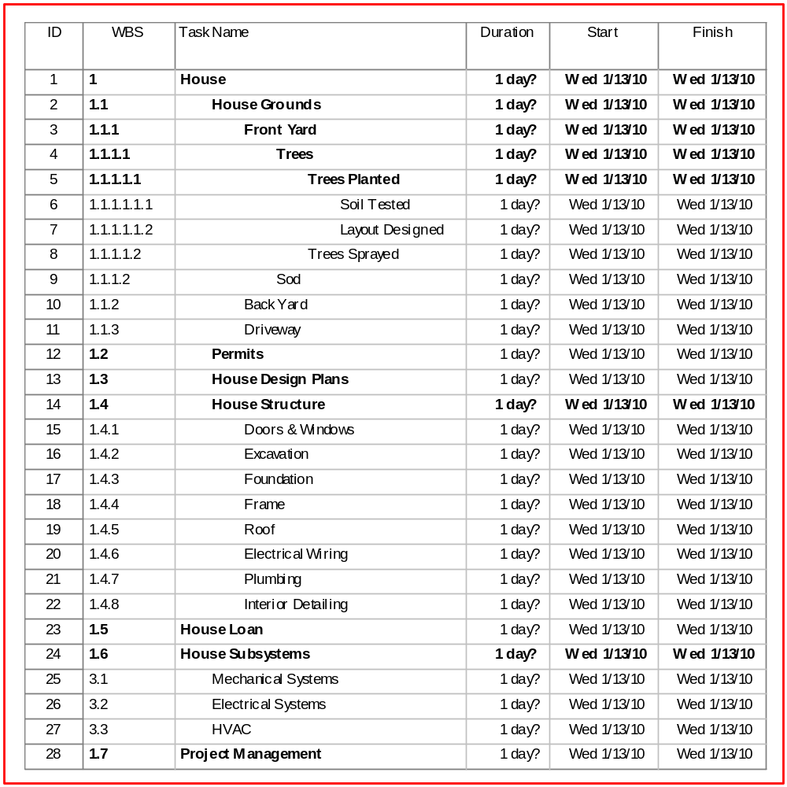

Baseline Schedule
[The baseline schedule (whether Project Schedule or IMS) is the first complete, agreed upon schedule approved for capture or copy for future reference. It is also the schedule from which future work will be measured; therefore, it is important to baseline the schedule before project work commences.
The frequency of re-establishing the schedule baseline is determined by each project. Some projects choose to re-baseline after accomplishing a major milestone or phase while others make it a policy to re-baseline only after an approved scope change. In either case, care must be exercised to avoid introducing scope creep through the re-baseline process.
Define when and how the schedule baseline is set for your project. Discuss the re-baseline process in Section 7.6, Establish New Baseline Schedule.]
Prior to commencing project work, and after the State’s schedule and the Prime Contractor’s schedule are integrated, reviewed, and approved, the schedule will be baselined. To baseline the IMS, the Project Scheduler saves the approved version under the new name “IMS_Baseline1<date>.mpp” and stores a copy in the project repository.
[Or if in Acquisition Phase:]
After the Planning Phase, prior to commencing acquisition tasks, and after the State’s schedule is reviewed and approved, the schedule will be baselined. To baseline the IMS, the Project Scheduler saves the approved version under the new name “Acq_Baseline1<date>.mpp” and stores a copy in the project repository.
The baseline will be re-established only upon scope change as approved by the project sponsor and as described in Section 7.6…

Scheduling Development Tool

Scheduling Development Tool Description
[Schedule data is compiled and updated in a scheduling tool to depict the time-sequenced flow of tasks, the actual work progress, and what remains to be completed. Microsoft Project is the standard schedule development tool used at OSI. List the scheduling development tool selected for your project and any other tools that assist in the schedule development process. Describe the tool’s primary features.]

Scheduling Tool Usage
[Document how to use the scheduling tool(s) when performing key scheduling processes. Utilize this section as an instructional aid for scheduling staff. Include time-saving tips, visual aids, or other helpful tutorial information. Keep high – level here and move details to the Appendix.

Schedule Input Monitoring

Compare Schedule Status to Time Status Reports
[Explain how the schedule is monitored against time status reports on which staff track and report their time on project activities. Define how discrepancies are addressed between scheduled hours and actual hours. Discuss the analysis process and how concerns, issues or risks associated with status are handled such as what occurs when a task is not progressing as planned. Also, if items are completed ahead of schedule, who is notified and what is done to take advantage of the early completion.]

Monitor Prime Contractor’s Schedule
[Define how the Prime Contractor’s schedule will be monitored and/or audited for RFP/contract compliance. Define the quality control efforts to be exercised by the State to insure the contractor’s schedule updates are sound prior to incorporating those updates into the IMS.
Note the frequency and criteria for schedule audits if planned. Define how the State will notify the contractor of needed corrective action as well as validate that the corrective action has resolved the issue in a timely manner.]

Schedule Management and Control
[Schedule management and control begins when the project schedule or IMS is first baselined. This initial baseline memorializes the project’s scope and sets the expectation for how and when the scope will materialize. Any proposed change to that scope will drive a schedule change management process. At this point, changes happen only if there is a change in requirements.
Schedule control addresses anticipating or correcting schedule variance. To do this, control tools and techniques are used to detect and forecast serious deviations from the baseline.
Insert a high-level diagram that depicts your schedule management and control process. Explain the process.]
Figure 7 depicts a high-level representation of the schedule management and control process used by the <Project Name>.

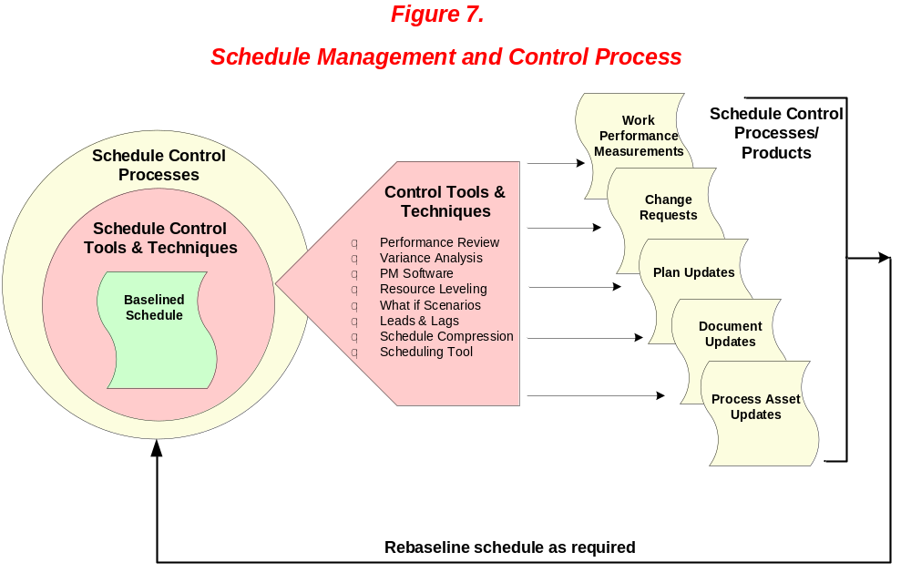

Schedule management and control processes begin once the IMS is baselined. As actual completion dates are monitored against the baseline, control tools and techniques are applied when to anticipate, avoid, and mitigate time loss as well take advantage of extra time due to early completions.
Depending on the tool or technique applied, schedule control products are generated which may themselves initiate its own control sub-process. The results derived from these products and processes are used to further monitor or modify the schedule in the form of a new baseline…

Schedule Control Techniques
[Schedule control processes serve to minimize schedule changes. Control techniques are designed to reveal the status of the schedule and suggest corrective action to bring the project back on schedule. A technique like the Critical Path Method calculates theoretical early start and early finish dates by performing forward and backward pass analysis through the network version of the schedule enabling the Project Scheduler to assess schedule risk. Float and Free-Float techniques help the Scheduler analyze where the schedule can be compressed when the project is behind schedule. Resource Histograms and Resource Leveling are used to resolve resource conflicts. Monte Carlo Simulation reveals the likelihood of completing the project on time where What-if Scenarios can be applied to a new fictitious baseline once Variance Analysis has revealed the cause of schedule variance.
Define the control techniques used in your project and when they should be applied. Describe the analysis process used to determine the root cause of schedule variation and how corrective action will be documented, audited for success, and captured in the project’s lessons learned database.]
Schedule control processes serve to minimize schedule changes. Some control techniques reveal the status of the schedule where others suggest corrective action to bring the project back on schedule.
Table 3 lists each schedule control technique used in the <Project Name>.
Table 3 – Schedule Control Techniques Defined

Technique | Definition
Performance Reviews | Performance reviews measure, compare, and analyze schedule performance such as actual start and finish dates, percent complete, and remaining duration for the work in progress.
Scenario Analysis | Allows decision makers to explore the implications of several alternative future states thus avoiding the danger of single-point forecasts. Conducted in a nonthreatening group setting, participants express beliefs, challenge assumptions, and alter their viewpoints to ultimately arrive at a strategic direction that is flexible and will remain so as actual events unfold.
Forward-Pass Analysis | Calculation of early start dates and early finish dates for uncompleted portions of all network activities. Determined by working forward through the network logic from the project’s end date.
Backward-Pass Analysis | Calculation of late finish dates and late start dates for uncompleted portions of all network activities. Determined by working backward through the network logic from the project’s begin date.
Bottom-Up Estimating | Cost, work, or resource estimate derived by first estimating the project’s individual elemental tasks at the lower levels of the WBS and then aggregating those estimates at successively higher levels of the WBS. For cost estimates, the project manager typically includes indirect costs, general, and administrative expenses, profit, and any reserves when calculating the total project cost.  This form of estimating is more accurate than making one large estimate.

Technique | Definition
Top-down Estimating | Approximating the size (duration and cost) and risk of a project (or phase) by looking at the project as a whole and comparing it to previously performed similar projects. The comparison may be made directly using “analogous estimating,” through an algorithm as in “parametric estimating,” or from the memory of estimating experts. Upon establishing an overall estimate for the project, sub-divide the estimate down through the levels of the WBS, for example, development will be 50% of the total, testing will be 25% etc; then sub-divide development and testing into their components and so on.
Critical Path Method | Predicts project duration by analyzing the sequence of activities (network path) that has the least amount of scheduling flexibility (i.e. float). Early dates are calculated by a forward pass using a specified start date. Late dates are calculated by a backward pass starting from a specified completion dated (usually forward pass’s calculated early finish date for the project.)
Monte Carlo Simulation | A technique in which the project team leader or project team computes and/or quantifies the complete and total project cost and/or project schedule a number of times through the use of input values that have been selected at random through the careful utilization of probability distributions or potential costs and/or potential durations. The purpose of utilization of the Monte Carlo analysis is for the sake of calculating a defined distribution scenario of possible total costs associated with the project as well as a range or possible completion dates of the project.
Resource Histogram | Vertical bar chart used to show resource consumption and availability by time period. Also called, resource loading chart.
Resource Leveling | - Practicing a form of network analysis in which scheduling decisions (start and finish dates) are driven by resource management issues such as limited resource availability or changes in resource levels.  - Evening out the peaks and valleys of resource requirements so that a fixed amount of resources can be used over time.  - Ensuring that a resource is maximized but not used beyond its limitations.

Technique | Definition
Variance Analysis | The goal is to determine the causes of a variance (that is to say, the difference between an expected result and an actual result).
Schedule Compression | Shortening of the schedule without reducing the project scope. Often requires an increase in project cost.
Crashing | Taking action to decrease the total project duration by adding resources (human and material) to the project schedule without altering the sequence of activities. The objective is to obtain the maximum duration compression for the least cost.
Fast Tracking | Compressing the project schedule by overlapping activities normally performed in sequence, such as Design and Build/Construction.
Inchstone Schedule Mgt | Part of the recovery plan for troubled projects that are behind schedule. Create detailed miniature milestones known as inchstones and set up the schedule linked to inchstone completion. Meticulously track schedule progress and record reasons for missed inchstones. Recalibrate schedule after a short period of time until project is back on schedule.
Free Float & Total Float  (or Slack) | Free float is the amount of time an activity can be delayed without delaying the early start of any immediately succeeding activities. Also called, secondary float.  Total float is the amount of time an activity from its early start without delaying the project end date. Derived by subtracting the early start from the late start or the early finish from the late finish and may change as the project progresses and as changes are made to the project plan. Also called slack, float, and path float.
Adjust Leads and Lags | Lead: A modification of a logical relationship that allows an acceleration of the successor activity such as when a task has a finish-to-start dependency with a ten-day lead, the successor activity can start ten days before the predecessor activity has finished.  Lag: A modification of a logical relationship that directs a delay in the successor activity such as when a task has a finish-to-start dependency with a ten-day lag, the successor activity cannot start ten days after the predecessor activity has finished.  Adjusting leads and lags is used to find ways to bring project activities that are behind into alignment with the plan.

Schedule Planning Analysis takes place early in the project when the WBS is formulated. The scheduling team will use MS Project to run What-if Scenarios to align the project owner’s vision of the project with the likely timeframe for completion. What-if Scenarios will again be run when a new completion date must be determined as a result of a requested change to the WBS during the course of the project…

Schedule Control Products
[Schedule control products such as work performance measurement data, change requests, Plan updates, process asset update, and document updates can result from applying schedule control techniques.
If products are produced by your management and control techniques correlate those in this section. Explain who receives the product and how it is used and archived.]

Schedule Change Request Process
[Schedule changes are driven by unanticipated work, new legislation with mandatory requirements, changes to county implementation schedules, federal comments, etc. Consider various drivers for schedule change and define who will authorize such changes given the driver (if they differ). Define which drivers constitute a “minor adjustment” and which, a “baseline change.”]
Overview the project schedule/IMS change request and control process. Explain how the schedule will be reviewed and approved prior to the change. Include a high-level work flow diagram of the change control process that includes how schedule changes will drive updates to the HMS, WBS, and RAM, or require TA notification.]
The Project Scheduler monitors the IMS by reviewing and incorporating updates on a weekly basis. The Schedule Change Management Process is applied when:
- New tasks or deliverables cause baselined milestones to slip
- The project scope will be changed
- A new constraint impacts the planned delivery date of the final project deliverable
- A key resource is redirected and no backup is planned…

Update Schedule
[Discuss how and when the schedule is updated upon monitoring of schedule inputs such as time-status reports by staff. Define how the schedule is analyzed for accuracy, slack, extra time, overruns, and issues and how the resulting analysis will be handled in each case.]
Each Program Manager or Team Lead reports percent-complete status of deliverables and tasks each Thursday…

Establish New Schedule Baseline
[Describe the process to change the IMS baseline and create a new project schedule or IMS. Define who must review and approve the change before the baseline can be changed. State where the prior baseline will be archived and the new baseline stored using what type of version control.]

Archive Schedule Change Support Materials
[Describe what documentation should be created and retained to justify and substantiate the baseline change.]

Schedule Status Reporting
[Define how and when schedule/IMS status is reported and who provides the information. Introduce the types of reports or charts used to report the actual dates against the baselined dates. Use the following sub-sections to elaborate on specific types of status reports.]
Weekly, the Scheduler generates a task list for each project resource which he/she receives by Monday at 10 a.m.…

Monthly Project Reports
[List the project reports in which schedule status is a part. Briefly define what the document is used for, the intended audience, and where the report can be accessed and from whom.]
Schedule status reporting is accomplished via four monthly reports:
- Project Master Schedule (Gantt Chart)
- Monthly Project Report
- Sponsor Monthly Project Report
- IPOC Monthly Report

Monthly Metrics and Trend Analysis
[List the reports that specifically detail the status of the schedule including completion status of tasks, activities, deliverables, and milestones as compared to the baselined plan. Define who produces these reports, their frequency, and where they are archived.]
Reports that specifically detail the status of the schedule including completion status of tasks, activities, deliverables, and milestones as compared to the baselined plan include:
- Planned vs. Actual Task Completions
- Schedule Variance by Activity
- Estimate to Complete (ETC)
- Critical Path Analysis
- New tasks added (or deleted) since last reporting period

Schedule Oversight Reports
[List the reports that are used to analyze current status and to identify potential or actual problems.]
Reports used to analyze current status and identify potential or actual issues include:
- Project Milestone and Deliverables Reports
- Task Lead Oversight Reports
- County Implementation Oversight Reports
- Tasks with Negative Slack Reports
- Contractual Product Status Reports
- Late or At Risk Task Reports

Schedule Closing
[Describe how to close a Project Schedule (e.g., Acquisition Phase) or IMS (SDLC or M & O Phase), given the project phase this SM Plan addresses. If closing practices vary depending on the reason for closing (such as Legislature terminates versus system decommission), note those differences. Define how the final schedules will be archived.]

Closing Reports
[Define which schedule-related reports will be generated when the project schedule or IMS is closed and who will generate and receive these reports.]
The Schedule Manager will provide input into the final schedule-related reports generated by the IPOC. These reports include:
- Post Implementation Evaluation Report (PIER)
- Federal Closeout Report

Archive Schedule Data and Tools
[Explain the archive and retrieval process for schedule data. Define which tools will be used as the repository and who is authorized to access the repository. Also explain the version control system used to differentiate documents.]
Appendices

Appendix A: Glossary & Acronyms

Acronym/Term | Description
Archive | An Archive is a secure repository of Configuration Items often stored offsite for additional security. Archiving is a process of storing Configuration Items in a secure manner. The purpose of archiving is to provide recoverability to a past state. Although the process for creating an archive is similar to that of taking a baseline, the method of storage for both is different. Whereas baselines are maintained in easily accessible media for reference during the project lifecycle, archives are stored on secure media.
Baseline  (also: Project Schedule Baseline) | Approved project schedule that serves as the basis for measuring and reporting schedule performance.
Change | Change and clarifications to any configured item including operational requirements and contract requirements.
Change Control | The tracking and management of proposed changes to an item's format, content, version and/or configuration. Change control applies to many different project office functions (e.g. requirements management, project management, quality management, contract management, etc.) as well as contractor delivered products.
Contractor | The external service provider that will develop, or otherwise supply a service to or component of a project deliverable. (See Prime Contractor)
Contract Work Breakdown Structure (Contract WBS) | The Contract WBS is a hierarchical tree diagram created by the Prime Contractor and which extends the Project WBS down to the levels 4, 5, 6, or beyond. The Contract WBS shows the activities (level 4), tasks (level 5), and sub-tasks (level 6) required to complete the deliverables shown on levels 1 – 3 of the Project WBS. Levels 4 – 6 are stated as the work outcome rather than as the work effort.
Deliverable | A work product produced by a contractor or consultant in accordance with the terms of their contract. It is measureable, tangible, verifiable outcome, result, or item that must be produced to complete a project or part of a project.
ETC | Estimated Time to Complete
FSR | Feasibility Study Report
IMS | Integrated Master Schedule – a schedule of events to be completed by both the Prime Contractor and State staff.
IT | Information Technology
Managers | The Department staff that oversee other department staff and are generally responsible for workload management.
Milestone | Identifiable point in a project or set of activities that represents a reporting requirement or completion of a large or important set of activities.
MS Project | Microsoft Project – An electronic scheduling tool.
OTech | Office of Technology Services
OSI | Office of Systems Integration
Prime Contractor | The contractor who has primary responsibility for developing or integrating the given system, or the primary contractor performing work on the system.
Project Management Body of Knowledge (PMBOK) | Information Technology project management supported by a discipline and a formal body of knowledge that defines a project from inception to implementation.
Project Participant | Individuals that are either dedicated project staff or individuals that provide executive level sponsorship and support.
Project Schedule | Time-sequenced plan to accomplish activities or tasks used to direct and control project execution. Usually shown as a milestone chart, Gantt or other bar chart, or tabular listing of dates.
Project Work Breakdown Structure (Project WBS) | The Project WBS is a hierarchical tree diagram that depicts the first three levels of the work breakdown structure beginning with level 1 that shows the project’s main deliverable (the final system) followed by level 2 – the major deliverables that make up the level 1 deliverable, followed by level 3 – sub-deliverables to the major deliverables. “Deliverable” may be a contracted deliverable of major work product.
Request for Proposal (RFP) | The RFP used to solicit proposals from the bidding community based on a set of defined requirements. The requirements may be general in nature allowing the bidders to propose a solution and the specific products to be used. The RFP describes the problem requirements, contractual terms, and required format for the proposal responses. The RFP also includes the specific criteria which will be used to evaluate the received proposals. The project works with DGS to ensure the RFP meets all appropriate state guidelines and regulations.
Resource Breakdown Structure (RBS) | A hierarchical structure of resources by resource category and resource type. The RBS may be organized by functional organizations.
Schedule Management | The process of developing, managing, and controlling the project schedule or integrated master schedule.
Stakeholder | (1) Individuals and/or groups who are involved in or may be affected by project activities. (2) The people who have a vested interest in the outcome of the project.
System Implementation | System implementation includes the activities of the project office and prime contractor to deploy the new system into the target environment or production. This includes but is not limited to, the installation of equipment, the installation of software, the rollout of new or modified business processes, and the delivery of supporting documentation. Implementation is complete upon system acceptance by the department’s maintaining organizations, and when the system is deemed “In production”. Since the project may be developed, implemented, and transitioned in iterations, these processes may be repeated and overlap between iterations.
TA | California Technology Agency (formerly the Office of the State Chief Information Officer)
Work Breakdown Structure (WBS) | A deliverable-oriented hierarchical grouping of project elements that organizes and defines the total scope of the project. Each descending level represents and increasingly detailed definition of the project work.

